**Rebuild VJM and VMM project**

1. Video   
   - Now, big banner in VJM is a content of Slide type in WordPress. Only one image so there are no animation in header of VJM.

* I’ll replace this picture by a iframe tag in HTML 5, so we can emble a youtube(facebook) video easily.

1. Menu and logo location in VJM + VMM  
   - To do this task, we have to modify Theme of these Wordpress site.

* I downloaded source code of VJM in server, and installed an offsite of VJM in my laptop
* I’ll modify theme, and test in my laptop, make sure ne site is ok before deploy it online.

Mock-up below here:

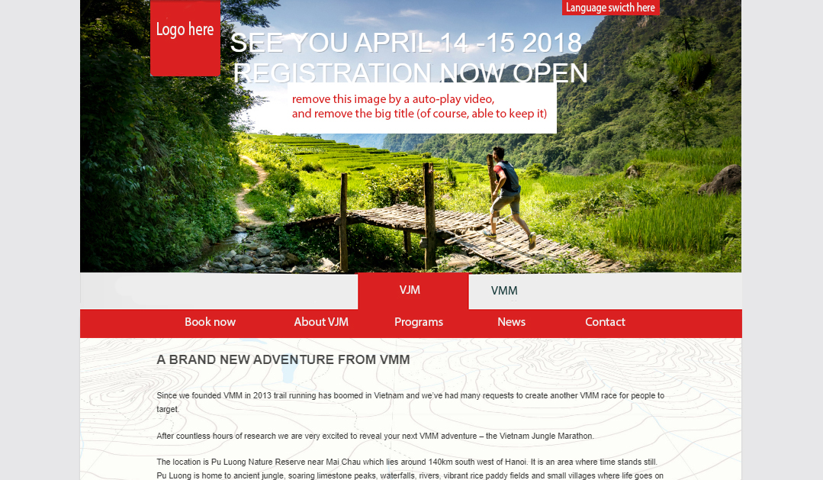

Hien, Xconnecting Vietnam